Hampshire Sure Start Children’s Centres
Family Registration Form

Welcome to Hampshire’s Children’s Centres. When you first visit one of our centres or access an activity/service, we ask you to fill out this form so that we can make sure that we are able to keep in contact with you about what we are running at the centres and help us to develop services further.
Please ask a member of staff if you would like help to complete this form.
I wish to register my family with Hampshire’s Children’s Centres and I declare that all information I have provided to the children's centre is true to my knowledge. By registering these details I understand that the information will be held confidentially on the Hampshire Children’s Centres database and only shared with partner organisations such as Hampshire County Council Services, health services, and children’s agencies, for the purpose of contacting families to provide appropriate and timely services, evaluate service provision and for statistical analysis.

Under the Data Protection Act 1998, any confidential information regarding your family will not be passed onto organisations outside of Children's Services partners, as mentioned above, without your consent, unless it is of a Child Protection nature, in which case information will be shared with appropriate agencies. Registration data may be shared with neighbouring authorities if you live outside of Hampshire County Council boundaries to ensure you receive appropriate services.

I have read and understood the above and give my consent for Hampshire’s Children’s Centres to store the information in this form and any further information provided.

Signed by parent |  | Date
Print Name


Fields that start with ‘*’ must be completed
Family Details
*Home Postcode |  | * Home Address
Home Telephone No. |  |  | GP Surgery

Your Details (Parent or Legal Guardian)
Title |  | *First Name |  | *Surname

*Your date of birth |  | *If pregnant then state due date

*Relationship to child(ren) e.g. mother, father etc

Mobile |  | Email

*Ethnicity Code (see back of form)

Are you a lone parent? Yes ◻ No ◻

Do you have any special needs ◻ and/or disabilities ◻

Address if different from family address

Are you fluent in English? Yes ◻ No ◻

If ‘No’ then what language do you speak?

Do you smoke? Y ◻ N ◻ Do you want to be contacted about stopping smoking? ◻

Your Partners Details or other carer (e.g. grandparent)
Title |  | *First Name |  | *Surname

*Your date of birth |  | *If pregnant then state due date

*Relationship to child(ren) e.g. mother, father etc

Mobile |  | Email

*Ethnicity Code (see back of form)

Are you a lone parent? Yes ◻ No ◻

Do you have any special needs ◻ and/or disabilities ◻

Address if different from family address

Are you fluent in English? Yes ◻ No ◻

If ‘No’ then what language do you speak?

Do you smoke? Y ◻ N ◻ Do you want to be contacted about stopping smoking? ◻

Your Child(ren)’s Details
 | Child 1 | Child 2
*First Name
*Surname
*Date of Birth
*Male or Female? | Male ◻ Female ◻ | Male ◻ Female ◻
*Ethnicity Code
(see back of form)
Disability? | Yes ◻ No ◻ | Yes ◻ No ◻
Special Needs? | Yes ◻ No ◻ | Yes ◻ No ◻
School or childcare setting (Please state name)

 | Child 3 | Child 4
*First Name
*Surname
*Date of Birth
*Male or Female? | Male ◻ Female ◻ | Male ◻ Female ◻
*Ethnicity Code
(see back of form)
Disability? | Yes ◻ No ◻ | Yes ◻ No ◻
Special Needs? | Yes ◻ No ◻ | Yes ◻ No ◻
School or childcare setting (Please state name)

How did you first find out about the children's centre? Please tick below

Health Visitor ◻ Midwife ◻ Friend ◻ Referral from another service ◻

Leaflet ◻ Registers Office ◻ Childcare Setting ◻

Other (please state) ………………………………………

Ethnicity Codes

Ethnicity | Code |  | Ethnicity | Code
White British | WBRI |  | White and Asian | MWAS
Bangladeshi | ABAN |  | White and Black African | MWBA
Indian | AIND |  | White and Black Caribbean | MWBC
Pakistani | APKN |  | White Irish | WIRI
Any other Asian background | AOTH |  | White Traveller of Irish Heritage | WIRT
Black African | BAFR |  | Any other White background | WOTH
Black Caribbean | BCRB |  | Gypsy/Roma | WROM
Any other Black background | BOTH |  | Any other ethnic group | OOTH
Chinese | CHNE |  | Do not wish to disclose | REFU
Any other Mixed background | MOTH

Thank you for taking the time to fill in this form

For further information on your local children’s centre then please visit
www.hants.gov.uk/childrens-services/childrenandyoungpeople/childrens-centres.htm

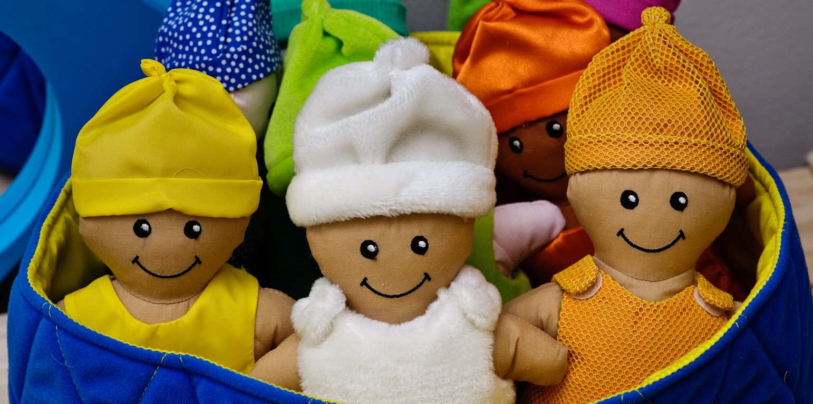

Hampshire’s children’s centres are delivered by the following organisations:
Action for Children, Fareham Community Partnership, 4Children in partnership with Southern Health and Children’s Links, Bushy Leaze Early Years Centre, Haven Children’s Centre and Lanterns Nursery School
For office use only - PC
Family Registration Number

