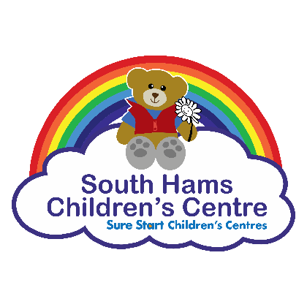
Were your children breastfed? (Please also tick if combined with bottle)
Data Protection
The information recorded in this form will be stored electronically and used to enable Children’s Centre staff to offer appropriate support. At times the information may be passed to other professionals working on our behalf to provide a service to you and to Devon County Council for monitoring and evaluation purposes. We are legally obliged to share information with other agencies if there are safety concerns about you or your child/children. All data will be kept in accordance with the Data Protection Act 1998 and you have the right to access any information we hold on you or your children.

Learning Journeys
South Hams Children’s Centre would like to do the best we can to support your children’s learning and development. The Children’s Centre create learning journeys to record your child’s development during their time with us. We mad share the learning journeys with other professionals and early years providers such as preschools to assist a smooth transition and any joint working. The learning journey will be shared with you and is securely created and stored via an early years online programme, information for which can be found at www.2simple.com. If you do not wish for your child’s learning journey to be stored or shared, please tick the box

Use of photographic images
Photographs/video may be taken during groups/activities provided by the Children’s Centre for use in promotion and/or service evaluation. If you do not give permission for photographs/video to be taken of your child/ren during Children’s Centre activities and used for this purpose please tick the box

Keeping informed
If you do not want to receive the Children’s Centre newsletter or information on Children’s Centres groups and service, please tick the box

Signed:

Print name:

Date:

Membership Form

www.southhamschildrenscentres.org.uk

Pathfields
Totnes
TQ9 5TZ

Tel: 01803 847626

E: southhamschildrenscentre@actionforchildren.org.uk

 | Main Carer | Second Carer
Name

Address
Postcode
Home Phone
Mobile
Relationship to child (e.g. mother)
If you are pregnant, what is the expected date of delivery? | ……/.…../…… | ……/.…../……
Email (please use CAPITALS)

Date of birth
Do you have a partner who lives with you? (main carer only) | Yes / No
Your employment status | Employed (inc. maternity/paternity leave)  Currently not employed, Training, Education, Long term sick or disabled  Full time parent/carer, Other: | Employed (inc. maternity/paternity leave)  Currently not employed, Training, Education, Long term sick or disabled  Full time parent/carer, Other:
Ethnic Group
(please see codes below)
Is English your first language? | Yes / No | Yes / No
If ‘no’ what is your first language?
Do you smoke?  Require smoking cessation info? | Yes / No  Yes / No | Yes / No  Yes / No
Do you have any long term health issue or disability? | Yes/No  If yes, please state: | Yes/No  If yes, please state:
Do you have any special requirements? e.g. access
Is anyone in the household employed?
Is anyone in the household a member of the Armed Forces

Any Other Asian Background AOTH
White & Asian MWAS
Any Other Mixed Background MOTH
Traveller of Irish Heritage WIRT
Gypsy/Roma WROM
Any Other Ethnic Group OOTH

White & Black Caribbean MWBC
White & Black African MWBA
Chinese CHNE
Indian AIND
Pakistani APKN
Bangladeshi AB

Ethnic Group Codes
White British WB
White Irish WI
Any Other White Background WOTH
Black –Caribbean BCRB
Black—Africa BAFR
Any Other Black Background BOTH
Rather not say REF

Any Other Asian Background AOTH
White & Asian MWAS
Any Other Mixed Background MOTH
Traveller of Irish Heritage WIRT
Gypsy/Roma WROM
Any Other Ethnic Group OOTH

Children in the Household
First Name | Surname | Date of Birth | Ethnic Group | Gender | Long term health issue, or disability? Please state | Special requirements e.g. access, allergies

