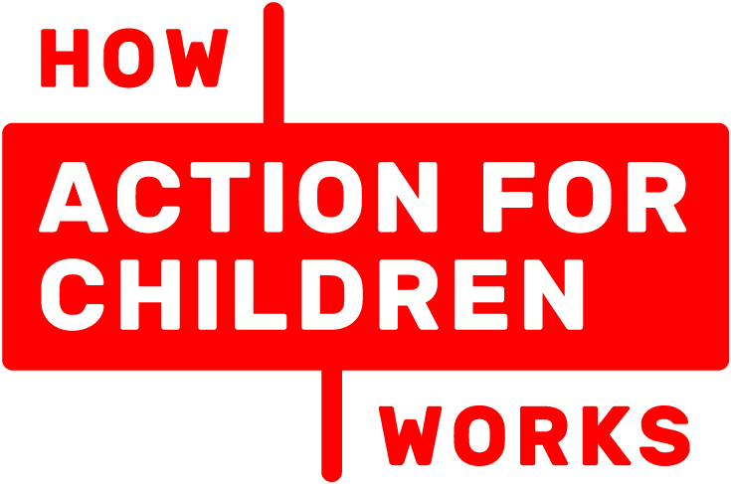

Advocacy and Independent Visitor Service

Action for Children

Electronic Referral Form
ALL FIELDS OF THIS FORM MUST BE COMPLETED IN FULL ELECTRONICALLY

Date:

Local Authority: Bournemouth Poole

If you believe an advocacy case is already open for this young person, please contact ArtBrokerage@Bournemouth.gov.uk for Bournemouth or childrenscontracts@poole.gov.uk for Poole, to agree more hours on an existing case.

Why does the young person qualify for the Service? | Please tick all that apply |  | Minimum Hours
Child (8-18yrs) who is in care |  |  | CIC review | 5.5
Child (8-18yrs) who is in care out of borough |  |  | CP conference | 4.5
Child (8–18yrs) who is making a complaint |  |  | complaint | 15-20
Child (8–18yrs) at initial child protection conference |  |  | If the child is out of Borough or has significant additional needs, please allow for this
Child (8–18yrs) at review child protection conference

What Service Would you like? | Please tick only one | Approx total number of hours working on case including contact with child, travel and paperwork
Advocacy |  | See above for guide:
Independent Visitor Service |  | Hours not applicable for Independent Visitors

Young Person’s Details
Name of Child/Young Person: | Address:
Alternative surname: | Town:
Preferred first name: | County:
Date of Birth: | Post Code:
Age: | Telephone Number:
Gender: | Religion:
Ethnic Origin: | First Language (Please specify)
Does child live out of Borough? Yes No  If yes, are they over 20 miles away? Yes No | Legal status: Child In Need Child Protection Child In Care  Other please specify:
Does the child/young person have any additional communication needs or any disability?
Yes No If yes, please specify:
Current placement type/living arrangements:
Are there any health & safety, risk or safeguarding issues our service should be aware of to keep the young person and worker safe? (e.g. drugs, alcohol, DV, animals in home)
Yes No Please specify
If risk is significant the referrer is responsible for sharing a risk assessment with our service
Does the young person agree to be contacted & seen by an advocate/IV?
Yes No
Please note we can only take referrals with the young person agrees.
Has the parent / carer or the person with majority PR, agreed for the child / young person to be contacted & seen by an advocate/IV? (They may be seen in school.) Yes No
Parent/carer’s Name:

Reason for Referral and Case Summary
If you have any specific questions you want us to ask the young person please include in this section. Please do not include any information that the young person is not aware of as we share this with them:

Do you have any additional information that we need to be aware of? Yes No
(If Yes, we will contact you when processing the referral.)

Are there any planned meetings/reviews you would like us to be involved in? Yes No
Type of Meeting:
Meeting Date: | Time: | Venue:
Chair of Meeting:

Other Key Agencies Involved (including Social Worker, school etc)
Contact Name: | Agency: | Contact Number:

Referrer’s Details
Contact Name | Email Address |  | Contact Number
Agency/Team (specific):
Referrer’s line manager and contact details

Please email this referral to:
BOURNEMOUTH REFERRALS | POOLE REFERRALS
ART Brokerage  ArtBrokerage@Bournemouth.gov.uk  For advice about advocacy referrals please call the Brokerage Team on 01202 458012 | Children’s Contracts  childrenscontracts@poole.gov.uk

